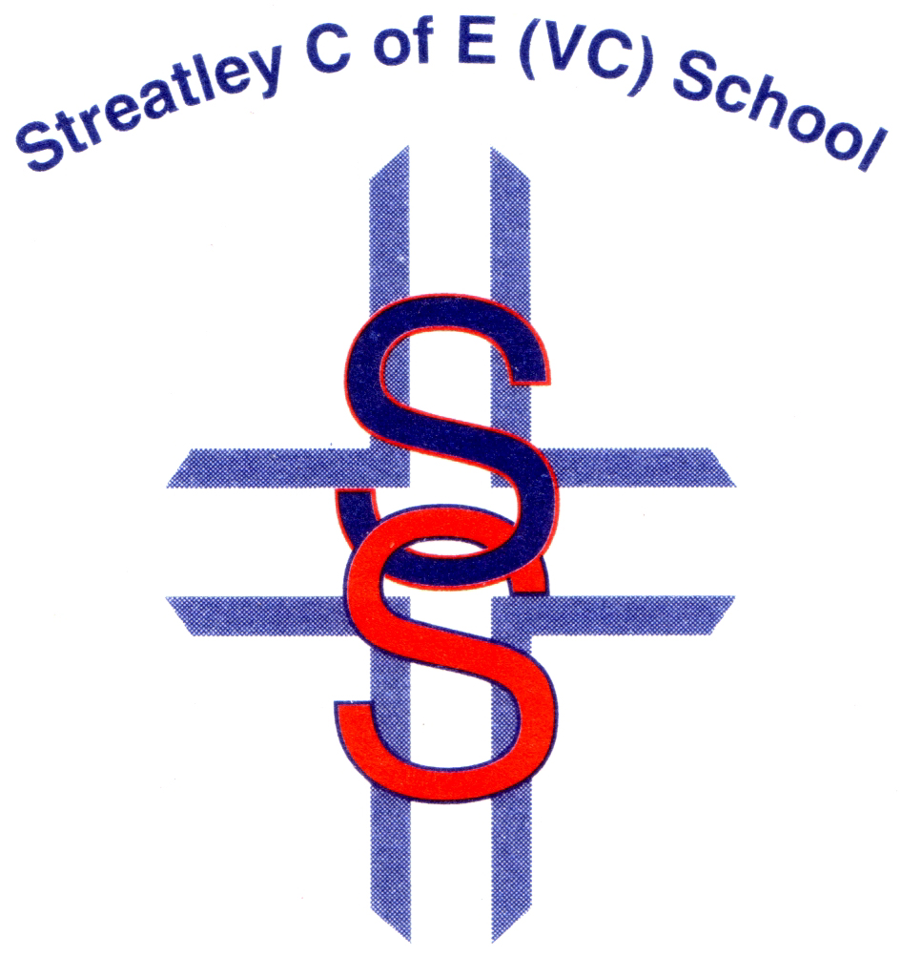

STREATLEY PRIMARY SCHOOL
Religious Education Policy
Document Control Information
Version | Date | Description of Changes
1 | Mar 2012 | Policy created.
2 | Mar 2015 | Unknown.
3 | Dec 2015 | Section Amendments: Our Approach to RE; Resourcing/Finance.  Section Deletions: Assessment of Religious Education; Time Allocation sections.
4 | Oct 2018 | Restructuring of document and changes to section titles and content.
5 | May 2019 | Section Amendments: Introduction.
6 | Nov 2021 | Section Amendments: Teaching, Learning and Assessment.
7 | Feb 2022 | Amendments by KW/BP
8 | Jan 2023 | Altered Key questions to Big questions under Curriculum and Teaching sections
9 | Feb 2024 | Reviewed. No amendments required.
10
Reviewed | 7th February 2024
Responsibility | RE Leader/Headteacher
Committee | Curriculum & Standards
Review Cycle | Annual
Next Review Date | February 2025
Signed | Sian Armitage

Contents
Introduction 3
The Legal Position 3
Purpose and Aims of RE 3
Curriculum and Time Allocation 3
Teaching, Learning and Assessment 4
Monitoring and Evaluation 4
Resources 4
The Right of Withdrawal 4

Introduction
At Streatley, together we grow as a tree within our community enabling us to be happy, healthy humans. “A tree is known by its fruit” Matthew 12:33. Our school is known by our children.
At Streatley Primary School, RE plays an important role in supporting the Christian vision of the school.
RE reflects the Christian values held and promotes understanding of all faiths and none. RE has the same high status as any other subject and contributes to the overall development of our pupils from all backgrounds and traditions.

The Legal Position
Every maintained school in England must provide a basic curriculum. This includes provision for RE for all registered pupils at the school, except for those withdrawn by their parents in accordance with Schedule 19 to the School Standards and Framework Act 1998. As a voluntary controlled school, RE is taught in accordance with the Locally Agreed Syllabus (The Pan- Berkshire Agreed Syllabus for Religious Education 2018-2023), while also reflecting the requirements of the Statement of Entitlement for Religious Education published by the Education Office of the Church of England in June 2016 and Valuing all God’s children (2nd edition, 2017). The statutory section 48 (SIAMS) inspection will evaluate the way that RE contributes to the Christian character of the school and the teaching of RE will reflect this requirement.

Purpose and Aims of RE
The purpose of RE is to teach children about the religious and non-religious world-views that they will encounter in modern Britain and enable them to engage in meaningful and considered dialogue with those of all faiths and none. This is religious literacy.
- To enable pupils to know about and understand Christianity as a living faith that influences the lives of people worldwide and as the religion which has most shaped British culture and heritage.
- To enable pupils to know about and understand other world religions and world views and their impact on society, culture and the wider world.
- To enable pupils to consider and express their own ideas and insights.
- To contribute to the spiritual, moral, social and cultural development of pupils and their own spiritual and philosophical convictions.
- To develop a positive attitude towards other people, respecting their right to hold different beliefs from their own and towards living in a society of diverse religions.

Curriculum and Time Allocation
The RE curriculum at Streatley Primary School follows the Locally Agreed Syllabus (The Pan- Berkshire Agreed Syllabus for Religious Education 2018-2023).
At Streatley Primary School we follow the Discovery RE scheme of work over a two-year cycle, whilst meeting the requirements of the Locally Agreed Syllabus. Each year group covers Christianity plus at least one other religion. The expected outcomes for each Key Stage will be achieved through the exploration of the Big Questions as provided in the Locally Agreed Syllabus. The time dedicated to RE is separate to the time given to Collective Worship. In KS1 this will amount to approximately 36 hours per year; in KS2 this rises to 45 hours per year.

Teaching, Learning and Assessment
RE is taught using an enquiry-based approach, that is challenging and robust. Learning will be organised to encourage the development of attitudes such as self-awareness, respect for all, open-mindedness, appreciation and wonder, as well as providing opportunities to engage with the appropriate strands of the British values agenda. All faiths will be treated respectfully and opportunities will be made to engage in age-appropriate, meaningful discussion. Where possible pupils will encounter believers and visit places of worship. A variety of resources, styles and techniques will be used to enable all children to make progress in RE, regardless of their starting points, ability or background. Each unit of work has a big question for the enquiry and focusses on four steps: engagement, investigation, evaluation and expression. Assessment activities are built into each unit of work and are in line with the assessment process in the foundation subjects. The progress that the children make is measured in terms of working towards, working at and working beyond the attainment descriptors for the unit. Records kept will include information about pupils’ experiences and judgements about their attainment and progress, as well as being used to inform planning.

Monitoring and Evaluation
The RE subject leader will monitor teaching and learning in RE in accordance with school policy. The RE subject leader will observe teaching, conduct book and planning reviews and pupil interviews when appropriate to assess the quality of teaching and learning. The Headteacher and governors will ensure that adequate monitoring takes place and that the impact of such activity is assessed.

Resources
The RE subject leader will ensure that RE resources are kept up-to-date and that staff are informed when new resources are purchased or made available. Resources will include online resources, books, artefacts and visitors to the school.

The Right of Withdrawal
Pupils may be withdrawn from RE or part of RE by a parent or guardian; teachers can exercise their right to withdraw from teaching the subject. However, we hope that all parents and teachers will feel comfortable with the type of religious education being taught at this school. Parents who wish to withdraw their children must provide written notification to this effect and provide suitable activities for their children. The school will keep the pupils safe, but will not provide any work for pupils who have been withdrawn.

